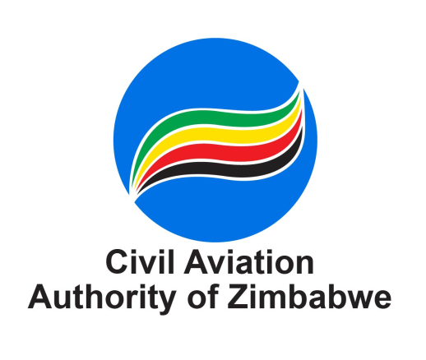

Aeronautical Information Management Department
3rd Level International Terminal Building
Robert Gabriel Mugabe International Airport, Harare, Zimbabwe
Direct Telephone: +263 242 585018 or +263 242 585006
Switchboard Tel: +263 242 585009 to 88, Ext: 3207/3426/3273/3422
E-mail: fltpermits@caaz.co.zw or flightbriefing@caaz.co.zw

LANDING AND OVER-FLIGHT PERMIT APPLICATION FORM

No. |  |  | Check  Box
1 | Date of Application
2 | Name of Aircraft Operator/Agent  (Attach copy of Air Operator Certificate for airlines or Aircraft Operating Agent Certificate for agents or Aircraft Registration Certificate for private operators)
3 | Physical Address
4 | E-mail Address
5 | Contact Telephone Number(s)
6 | Aircraft Registration(s) and Call – signs
7 | Aircraft Type(s)
8 | Maximum Take-Off Weight (Kilograms)
9 | Certificate of Airworthiness Validity  (attach a copy)
10 | Pilot-In Command License Validity  (attach a copy)
11 | Aircraft Classification Number (ACN)
12 | Full routing including Departure and Destination Airports
13 | Entry- and Exit points
14 | Number of Flights
15 | Date(s) of Flight
16 | Departure and Arrival Times
17 | Purpose of Flight
18 | Number of Passengers
19 | Payment Method: (Choose applicable below)
a). | Credit/Pre-paid Account  (Write your account number)
b). | Cash/Bank Transfer  (Attach Proof of payment)
20 | Special Requirements:  (Choose applicable below)
a). | Non-Type Certified Aircraft permit  (Attach Special Permit Approval from Airworthiness Manager)
b). | Landing permit at Zimbabwe Defense Forces (Attach Authorization letter)
c). | Landing permit at Zimbabwe National Parks (Attach Authorization letter)
d). | Landing permit at Zimbabwe Ministry of Mines (Attach Authorization letter)
e). | Landing permit at Category III Aerodrome  (Attach Owner’s Authorisation letter)
f). | Landing permit at CAT I and II Aerodrome with ACN greater PCN  (Attach Airport Manager Authorization letter)

NB: Submit flight permit applications at least 6 hours prior to flight
Customer complaints/feedback please contact ais@caaz.co.zw OR+263242 585100

FOR OFFICIAL USE ONLY

APPROVED / NOT APPROVED
Permit Number: |  | Validity Period
Date Received: |  | Date Issued:
Processed By: |  | Designation: | S/AIM Officer
Verified By: |  | Designation | Principal AIM & PANS-OPS Officer
Approved By: |  | Designation: | AIM & PANS-OPS Manager
Permit is issued under the authority of the Director General - Civil Aviation Authority of Zimbabwe

